## ME 322 Machine Design

## Assignment 6 (Set 3) Submission Date:19/04/22

1. Write a short note on needle bearings.
2. Explain the different remedies used to avoid surface wear in bearings.
3. Write the guidelines for selection of lubricants for rolling contact bearings.
4. Explain the ISO plan for the dimension series of the bearing having bore diameter of 70 mm.
5. Write about mounting of bearings.
6. Write about different types of fits used in design of bearings.
7. Explain Abrasive wear and corrosive wear in bearings.
8. Derive the expression for dynamic load capacity of ball bearings under varying loads and speeds.
9. What is reliability of bearings? Explain its relation with bearing life.
10. Write some applications of needle bearings.
11. A shaft transmitting 50 kW at 125 rpm from gear G1 to gear G2 and mounted on two single row deep groove ball bearings B1 and B2 is shown in the figure below. The gear tooth forces are Pt1 = 18915 N, Pt2 = 8749 N, Pr1 = 6893 N and Pr2 = 4876 N. The diameter of the shaft at bearings B1 and B2 is 70 mm. The load factor is 1.4 and the expected life for 90% of the bearing is 12,000 hr. Select suitable ball bearing.

|  |  |  |
| --- | --- | --- |
| Inner dia. of bearing, d (mm) | Basic load rating, C (N) | Desig-nation |
| 75 | 28100 | 16014 |
| 37700 | 6014 |
| 61800 | 6214 |
| 104000 | 6314 |
| 143000 | 6414 |

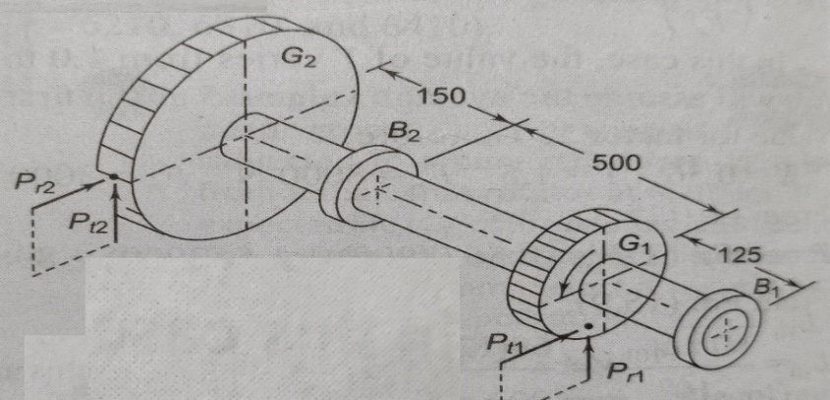

1. A single-row deep-groove ball bearing is subjected to a radial force of 8 kN and a thrust of 3 kN. The values of X and Y factors are 0.56 and 1.2 respectively. The shaft rotates at 1440 rpm. The diameter of the shaft is 75 mm and Bearing no 6615 (C= 112000 N) is selected for this application.
   * 1. Estimate the life of the bearing with 90% reliability.
     2. Estimate the reliability for 20000 hr life.